## **UNIT 4.4**

## **RELATIONAL DATABASE SYSTEMS**

**TUTOR NAME: IBTISAM MOGUL**

FATIMA EJAZ BARRI

Contents

**UNIT 4.4** 1

**RELATIONAL DATABASE SYSTEMS** 1

The three levels of Database architecture 6

What is big data? Data: 6

Social media 7

Types of big data 7

Structured 7

Unstructured: 8

Semi-structured 8

3vs of data big 9

## LO1

## **1.1 Explain the database management system (DBMS)**

## Database:

A shared collection of logically rated data, and a description of this data, designed to meet the information needs of an organization.

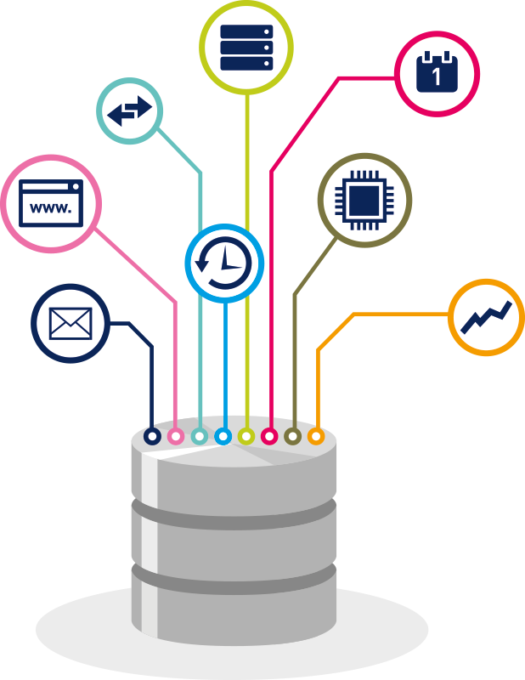

## Database management system

A software system that enables users to define, create, maintain and control access to the database. These commands are used to load, retrieve or modify existing data from the system. That is DBMS also facilitates oversight and control of database, enabling a variety of administrative operations such as performance monitoring tuning, and backup and recovery.

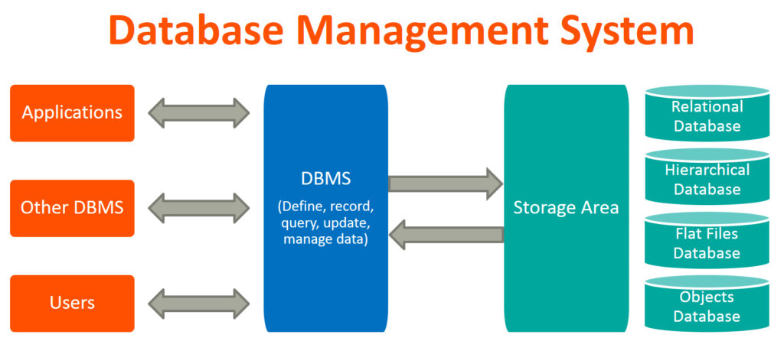

## Advantages of database management system

The main advantages of DBMS are described below.

## Controlling data redundancy:

In non-database system, each application program has its own private files. In this case, the duplicated copies of the same data is created in many places. In DBMS, all data of an organization is integrated into a single database file. The data is a recorded in only one place in the database and it is not duplicated.

## Sharing of data:

In DBMS, authorized users of the organization can share data. The database administrator manages the data and gives rights to users to access the data. Many users can be authorized to access the same piece of information simultaneously. The remote users can also share same data. Similarly, the data of same database can be shared between different application programs.

## Data consistency:

By controlling the data redundancy, the data consistency is obtained. If a data appears only once, any update to its value has to be performed only once and the updated value is immediately available to all users, if the DBMS has controlled redundancy, the database system enforces consistency.

## Integration of data

In database management system, data in database is stored in tables. A single database contains multiple tables and relationships can be shared between tables or associated data entities. This makes easy to retrieve and update data.

## Integration constraints

Integrity constrains or consistency rules can be applied to database so that the correct data can be entered into database. The constraints maybe applied to data item within a single record or the may be applied to relationships between records.

## Data security

Form is very important object of DBMS. You can shared forms very easily and quickly in DBMS. Once a form is shared, it can be used many times and it can be modified very easily. The created forms are also saved along with database and behave like a software component. A form provides very easy way (user-friendly) to enter data into database, edit data and display data from database. The non-technical users can also perform various operations on database through forms without going into technical details of a database.

## Report writers

Most of the DBMS provide the report writer tools used to create reports. The users can shared very easily and quickly. Once a report is created, it can be used may times and it can be modified very easily. The created reports are also saved along with database and behave like a software component.

## Backup and recovery procedures

In a computer file-based system, the user creates the backup of data regularly to protect the valuable data from damage due to failures to the computer or application program. It is very time consuming method, if amount of data is large. Most of the DBMS provide the backup and recovery subsystems that automatically create the backup of data and restore data if required.

## Control over concurrency

In a computer file-based system, if two users are allowed to access data simultaneously, it is possible that they will interfere with each other. For example, if both users attempt to perform update operation on the same record, the one may overwrite the values recorded by the other. The most DBMS have sub systems to control the concurrency so that transactions are always recorded with accuracy.

## Data independence

The separation of data structure of database from the application program that uses the data is called data independence.in DBMS you can easily change the structure of database without modifying the application program.

## Image result for Applications of DBMS**Applications of database management system**

Banking system: for storing customer info, tracking day-to-day credit and debit transactions, generating bank statements etc.

Telecom: there is a database to keep track of the information regarding calls made, network usage, customer details etc. without the database systems, and it is hard to maintain that huge amount of data that keeps updating every millisecond.

Airlines: to travel though airlines, we make early this reservation information along with flight schedule is stored in database.

Manufacturing: it is used for the management of supply chain and for tracking production of items. Inventories status in warehouses.

Educational: database systems are frequently in schools and colleges to store and retrieve the data regarding student details, staff details, course details, exam details, payroll data, attendance details, fees details etc. there is a hell amounts of inter-retried in an efficient manner.

Online shopping: you must be aware of the online shopping websites such as amazon, flipchart etc. These sites store the product information, your addresses and preference, credit details and provide you the relevant list of products based on your query. All this involves a database management system.

**API example:**

A site that monitors more than 15,500 APIs, the programmable web lists google maps, Facebook, YouTube, Flickr and amazon brand marketing as some of the most prominent APIs. The list below provides some examples of common APIs:

1. Google maps API: google maps allow developers use a JavaScript or flash interface to embed google maps on web pages. The google maps API works on mobile devices and web browsers.
2. YouTube API: the google APIs allows developers to integrate videos and functionality form YouTube into websites or applications. YouTube APIs include the YouTube analytics API, the YouTube data API, the YouTube live streaming API, and the YouTube game APIs.
3. Flickr API: developers use the Flickr API to access data from the flick photo-sharing networking. The Flickr API is a collection of callable methods, and some endpoints of the API.
4. Twitter APIs: twitter has two available. The rest allows developers to access key twitter data, and the search API provides developers with ways to communicate with twitter search and data on trend.
5. Amazon product advertising API: amazons brand advertising API offers developers with access to amazons’ product selection and discovery tools to advertise amazon’s products for website monetization.

# 1.2 The three levels of Database architecture

There are three levels of the database architecture following:

External level: the users view of the database. This level describes that part of the database that is relevant to each user.

# 1.3 What is big data Data:

The numbers, characters or symbols on which a device conducts operations that can be processed and distributed in the form of electrical signals, and recorded on magnetic, optical, or mechanical storage devices.

Big data is also data but it has an enormous size. Big data is a term used to describe a collection of data which is small in scale which expands exponentially over time. In short, this data is so large and complex that none of the conventional data management systems can efficiently store or process it.

Below are some examples of big data systems:

The New York stock exchanges generates about one terabytes of new trade data per day



# Social media

The statistic shows that 500 terabytes of new data get ingested into the databases of social media site Facebook, every day. This data is mainly generated in terms of photo and video uploads, message exchanges, putting comments etc.



# Types of big data

Big data’s could be found in three forms:

1. Structured
2. Unstructured
3. Semi-structured

# Structured

Every data that can be stored, viewed, and interpreted in set format is considered structured data. Over time, computer science expertise has been more active in creating methods for dealing with and deriving interest from such data (where the format is well defined in advance).

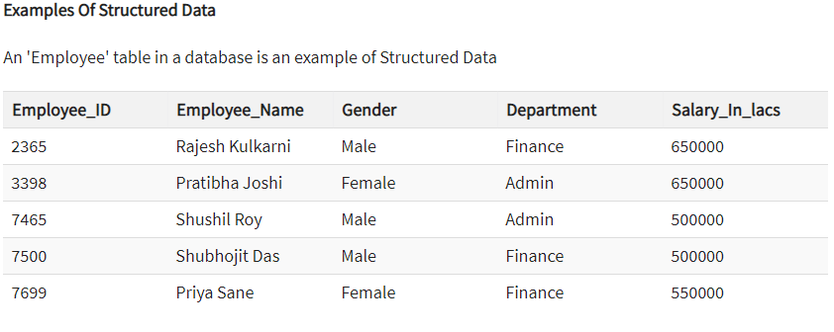

# Unstructured:

Any data with a shape or function unknown is labelled as unstructured data. As well as the as the scale being immense, unstructured data faces multiple challenges in terms of its retrieval to extract meaning from it. A typical example of unstructured data is a heterogeneous source of data which contains a mixture of simple text files, photographs, videos etc.

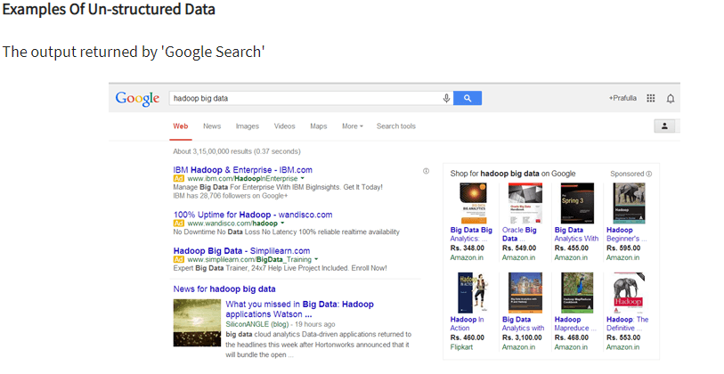

# Semi-structured

Semi-structured data may contain data in both ways. We can see semi-structured data as structured in form but it is not specifically defined in relational DBMS with e.g. a table description. Semi- structured is an example of data contained in an XML format

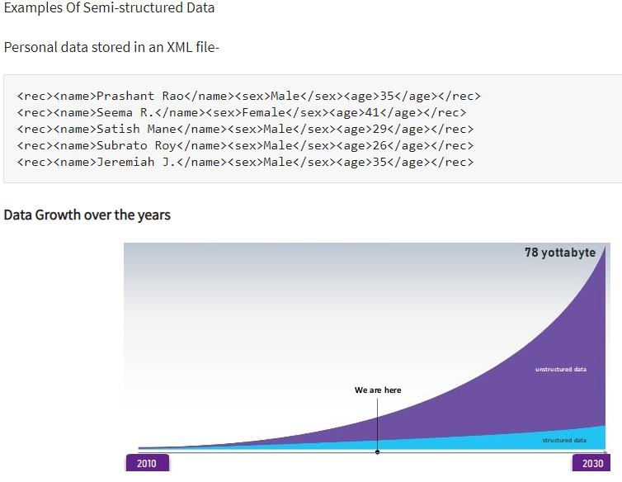

# 3vs of data big

The following 3 dimensions are commonly used for more precise. These dimensions are generally referred to as 3vs of big data

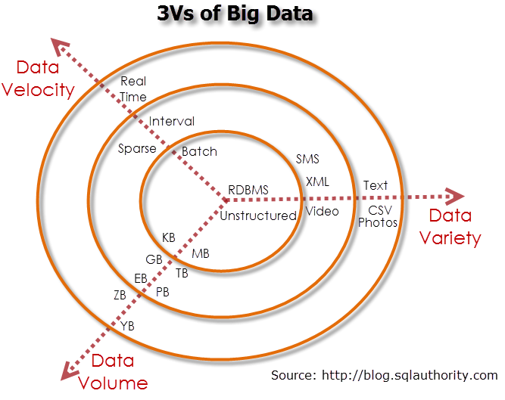

## Velocity:

Velocity describe the frequency of generation, capture and sharing of the data. Recent Development that’s more data is generated in much shorter cycles not only by consumers but also by businesses. This data can only be capitalized on by velocity companies if the data is collected and transmitted in real- time.

## Variety:

## Volume:

## Applications of big data

Big data has a lot of applications in a different field. These are fields in which big data is employed.

Government operation:

## What is transaction processing?

* **4properties of transactions**

**Sates of transaction with diagram**

**Transaction manager**

**What is data integrity**

**Importance of integrity**

**GIGO**

**What is data quality?**

THE DETAILS OF YOUR ENTITIES IN THE DATABASE

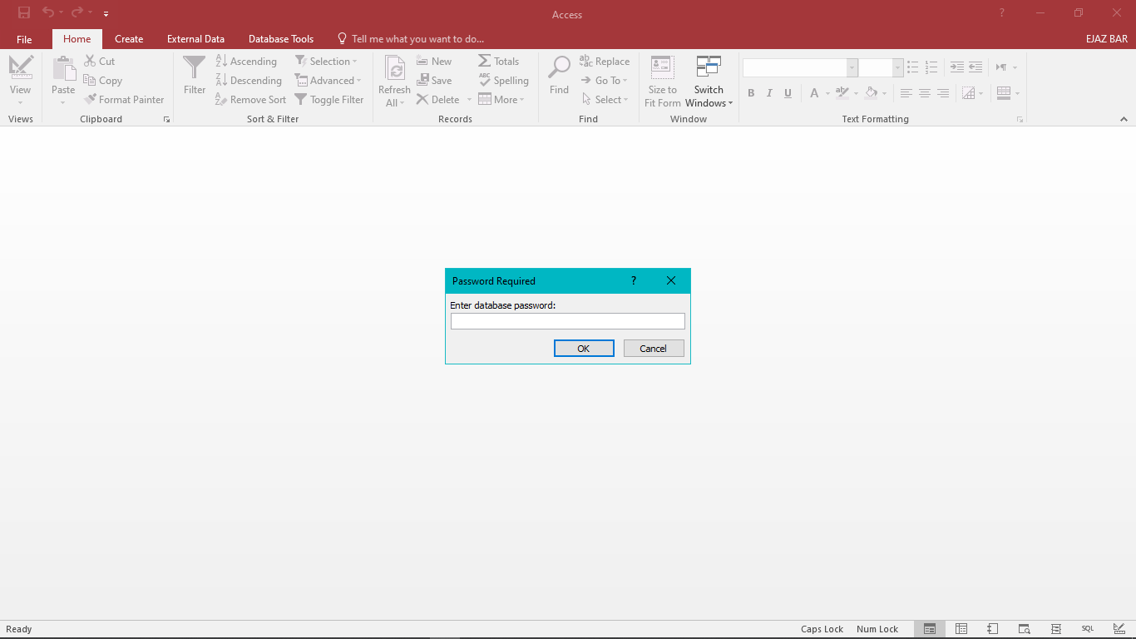

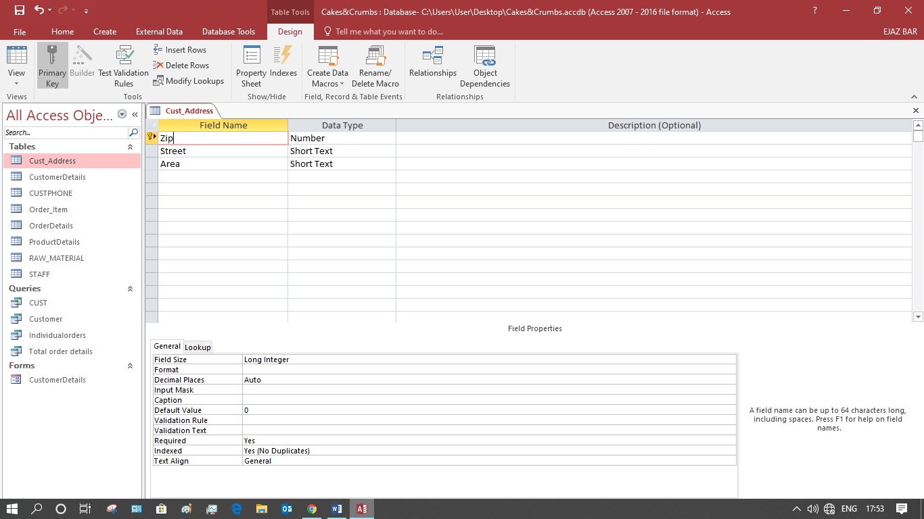

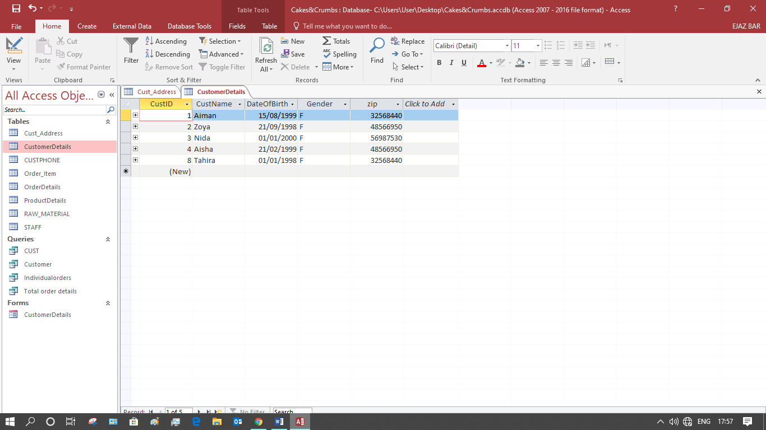

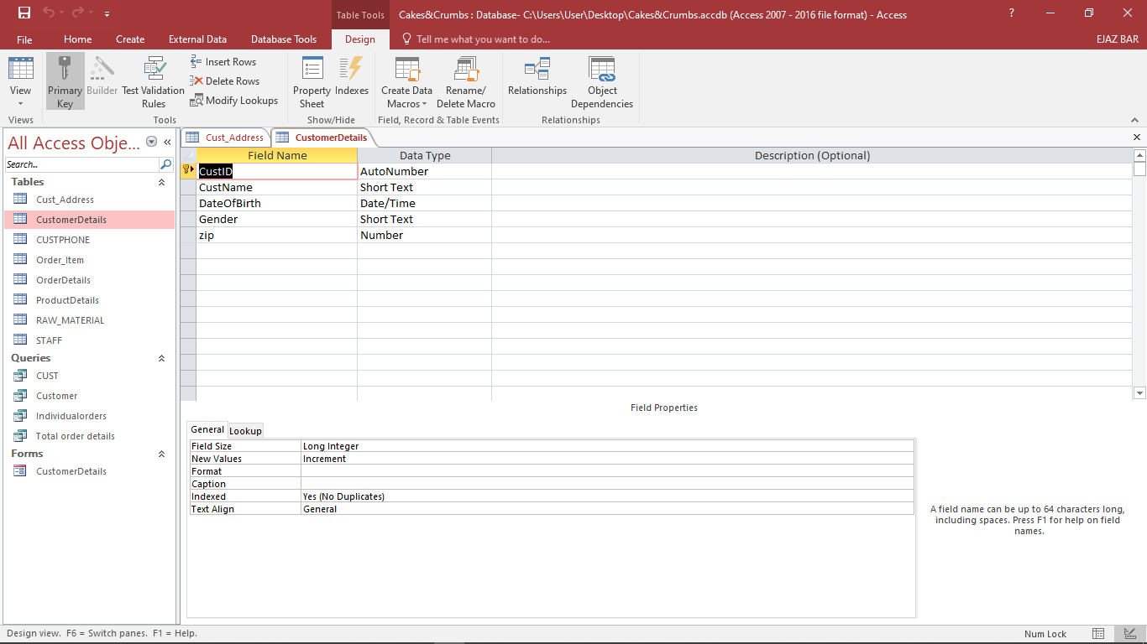

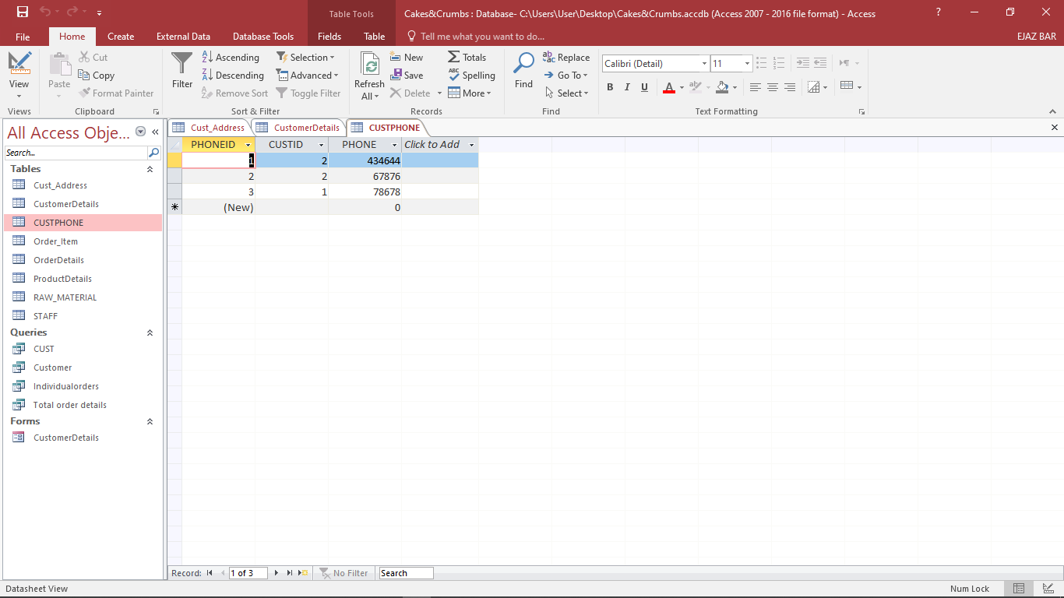

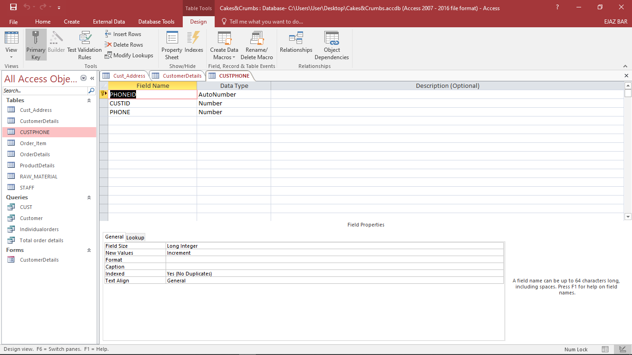

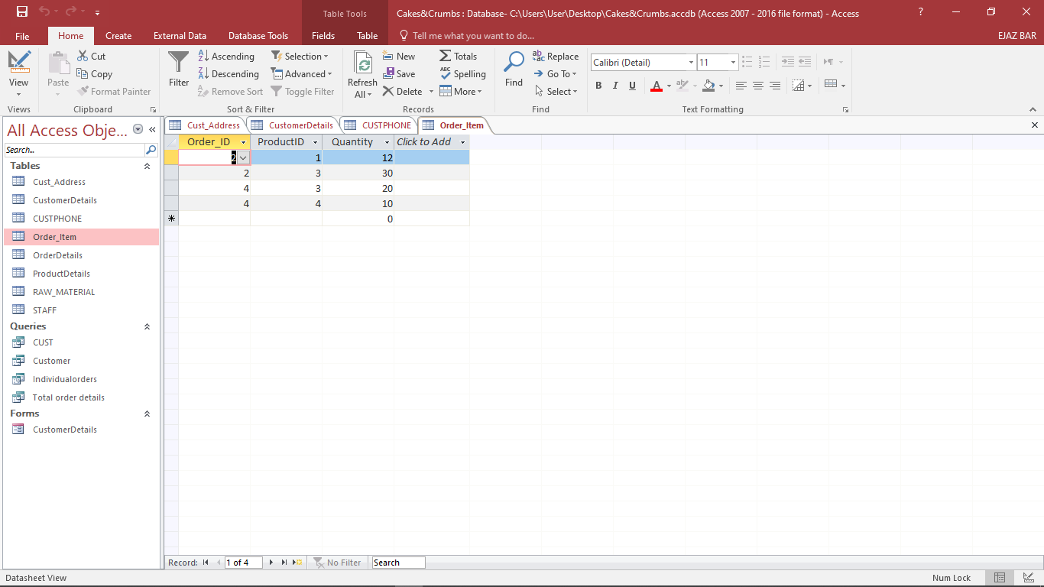

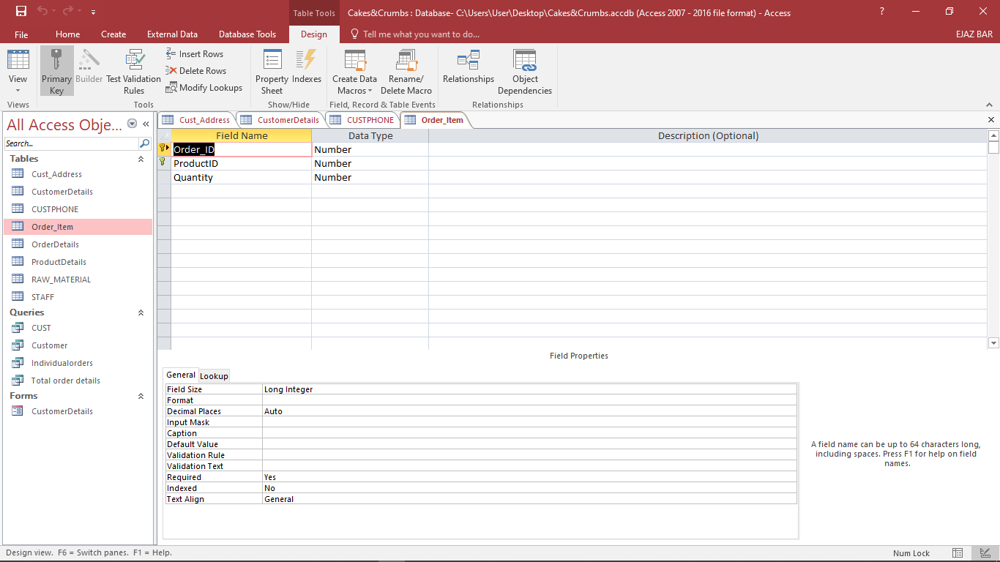

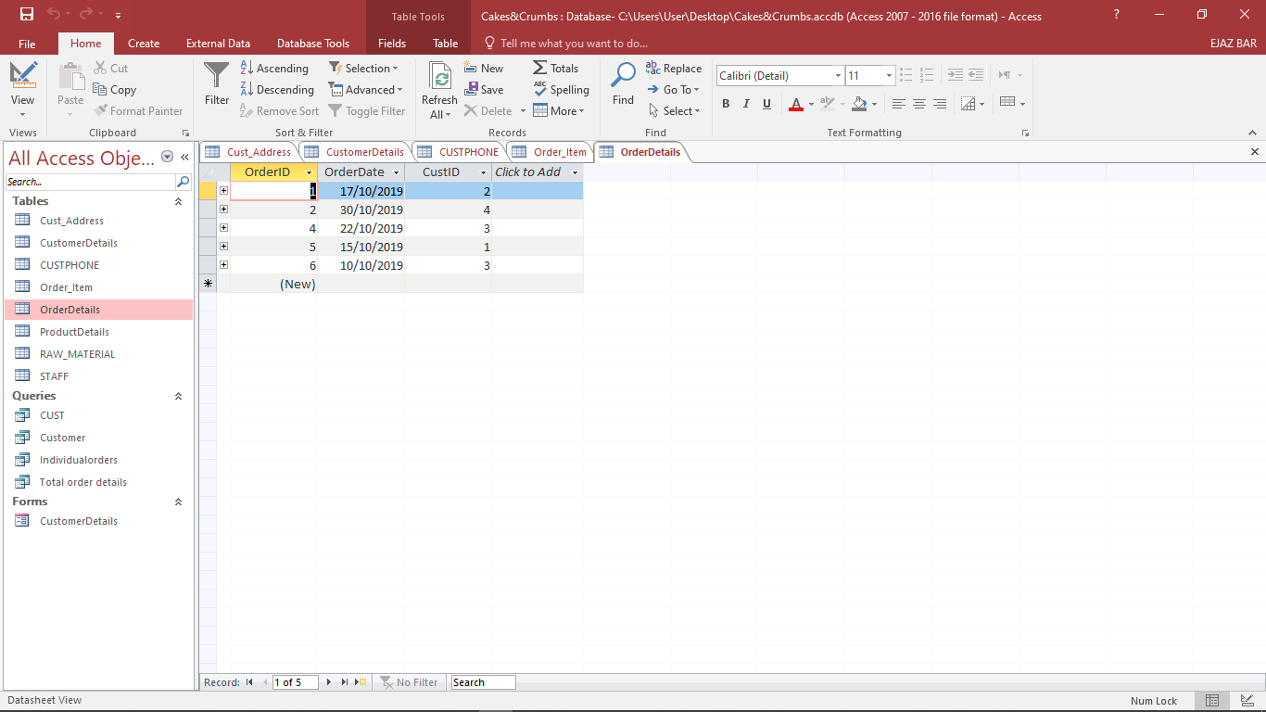

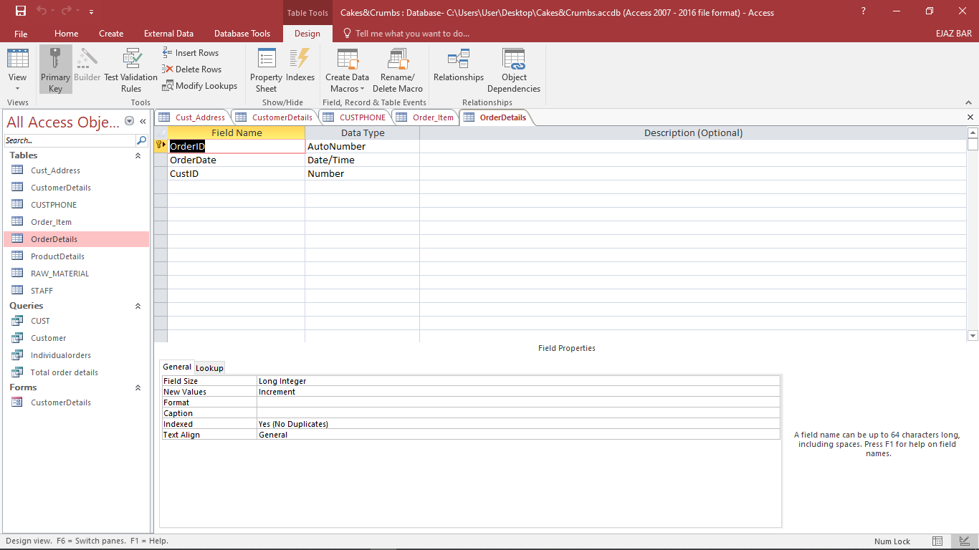

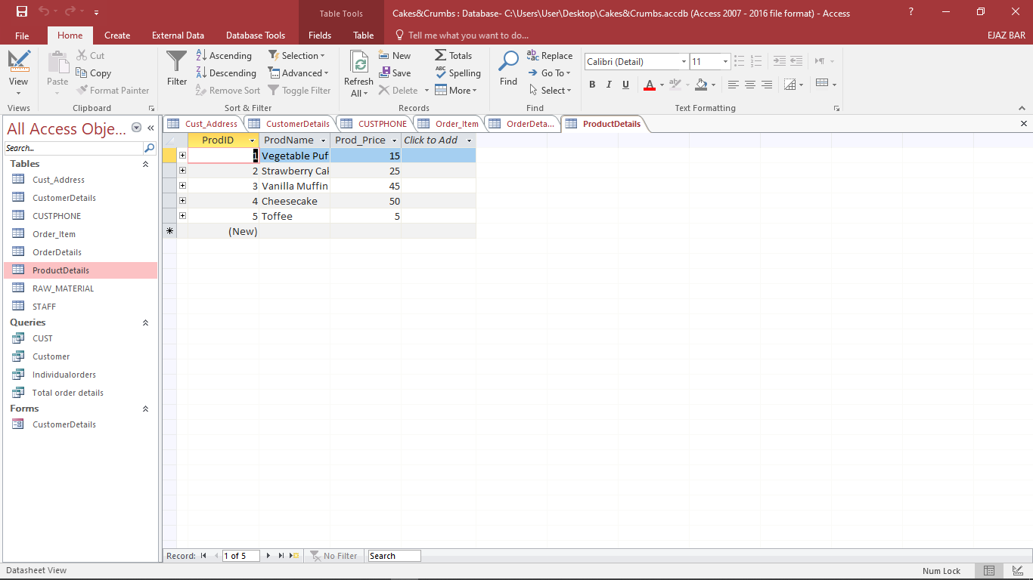

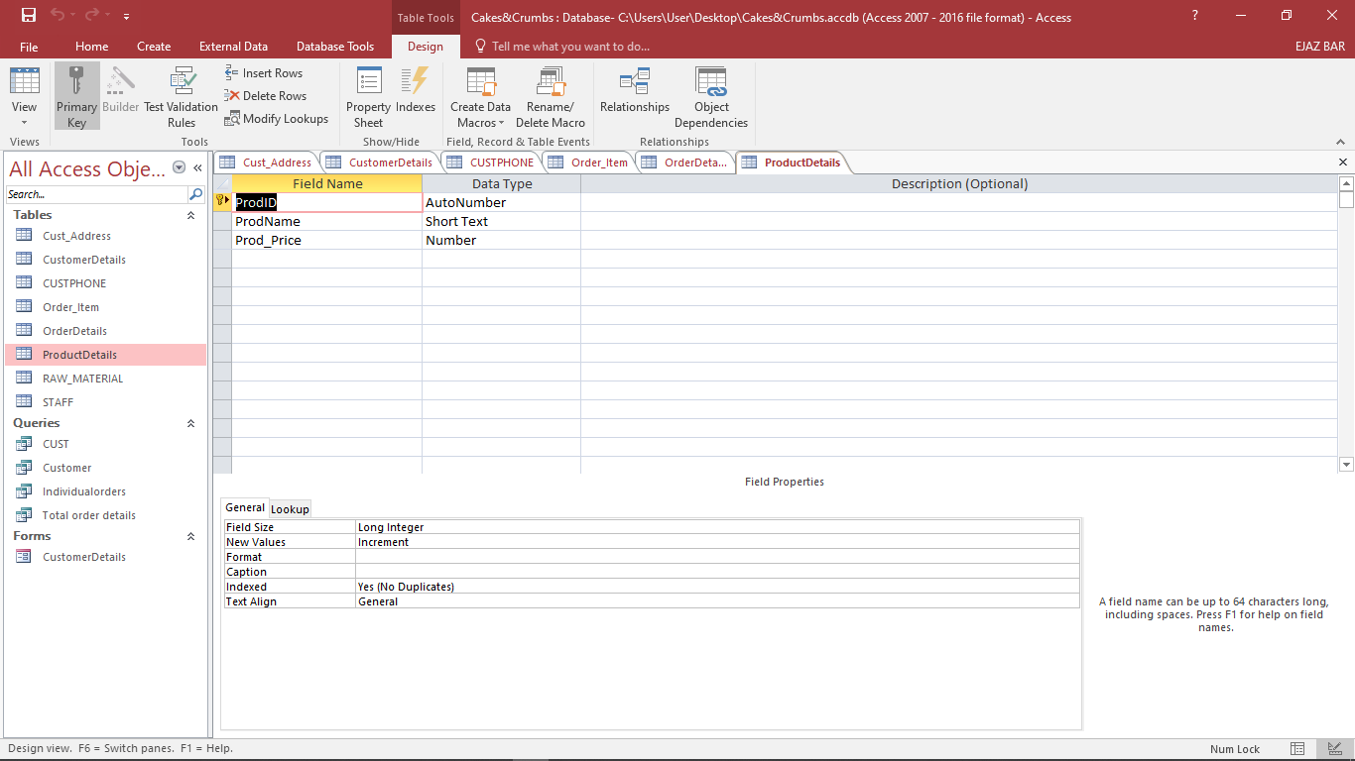

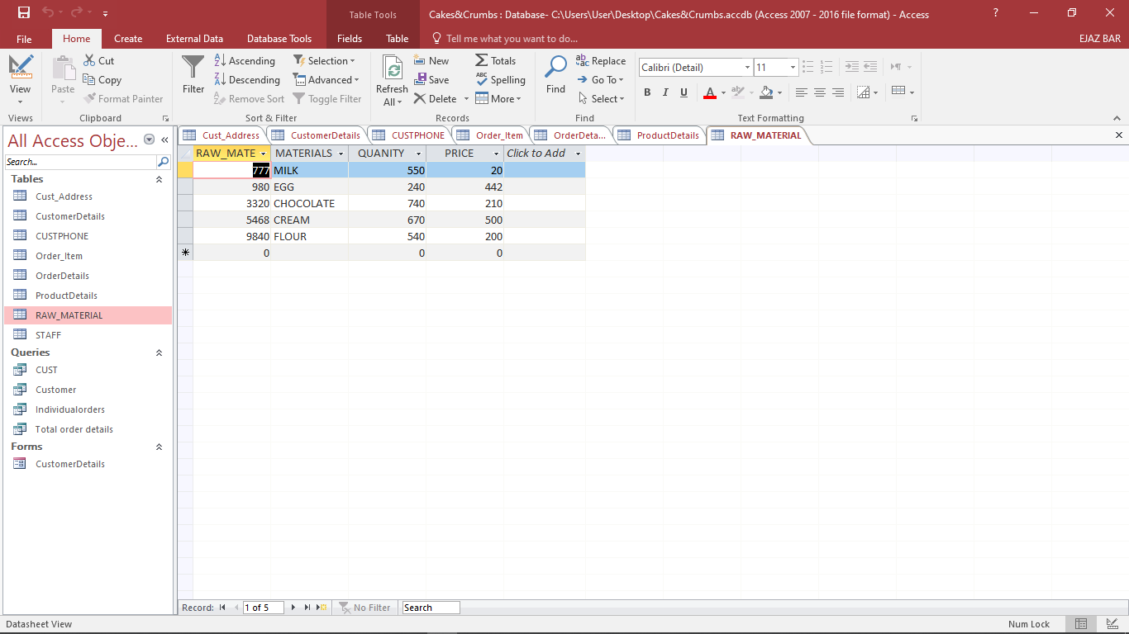

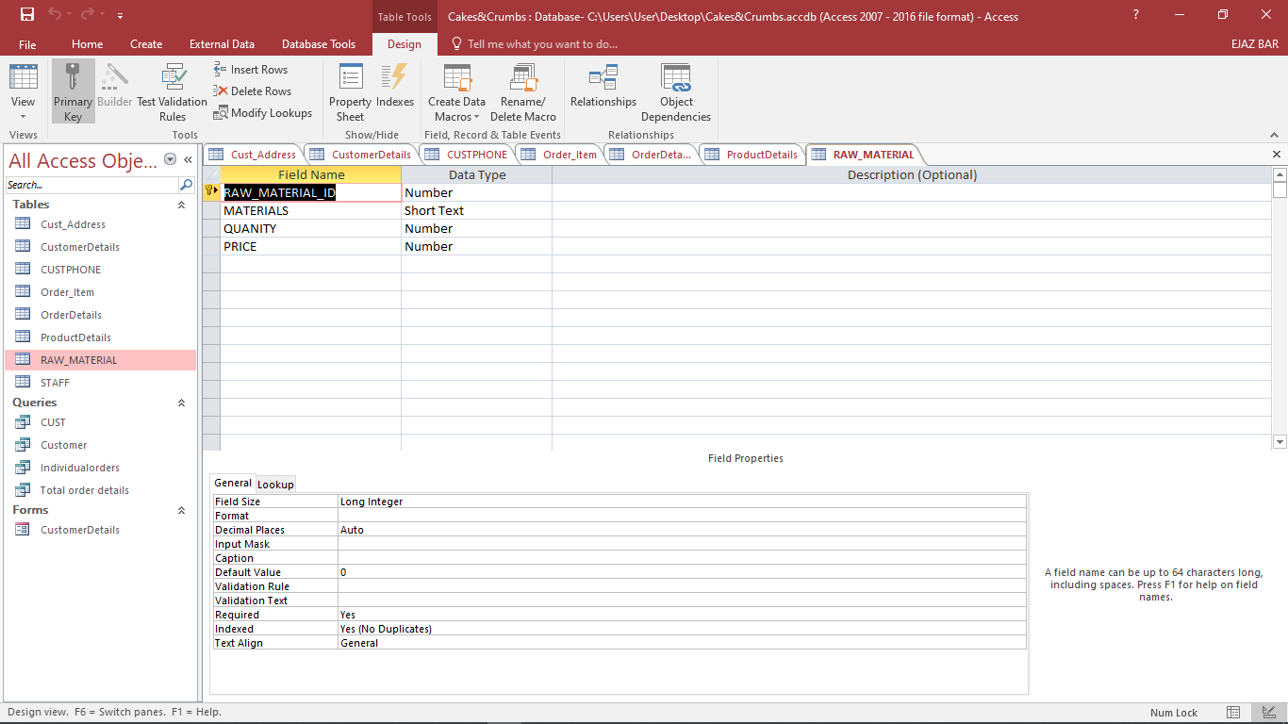

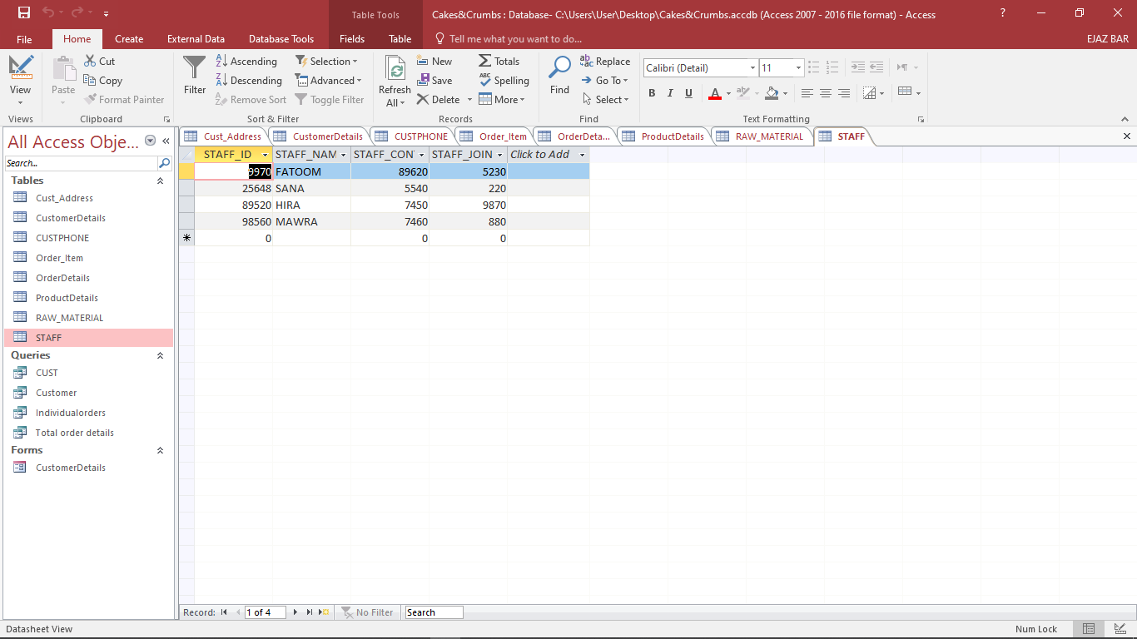

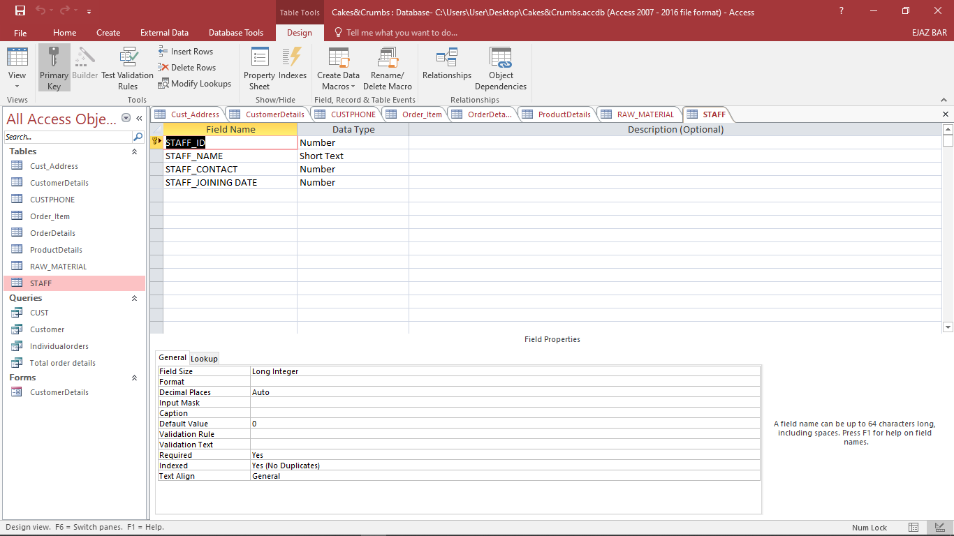

Entity 1: raw materials:

## Bibliography:

Vangie Beal, (1996) API Application program interface {online} available from: <https://www.webopedia.com/TERM/A/API.html> [Accessed 28 may 2021].

Stefan Schmidt, (2013) the 3 Vs of big data {online} available from: <https://www.the-future-of-commerce.com/2013/03/07/the-3-vs-of-big-data/> [Accessed